**MonteCarlo Townhome Gate Instructions you need to know!**

If you have TMobile or MetroPCS and your code at the gate is giving a busy signal when dialed – this is because the carrier is blocking the call as a SCAM Call.

To fix this you must allow the phone number to come through to your phone. Once the steps are successfully completed – when you get a call from the gate the contact will display.

To open the gate – answer the phone and press “9” on your phone to open the gate.

Before you begin – Make sure that you have the phone # saved in your contact list as “The gate”

Go into the contact and make sure it is not a “blocked number” – if so – Unblock it

And then complete ALL the steps below.

**STEP 1:** Go the app store and search for the tmobile scam shield app

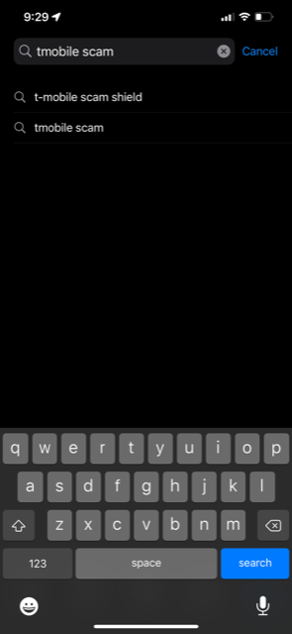

**Step 2:** Download the T-Mobile Scam Shield App

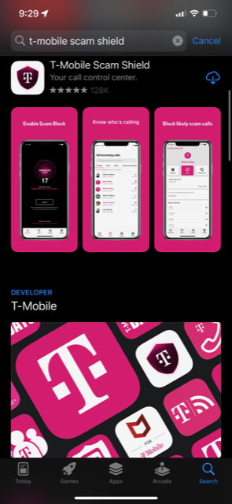

**Step 3: Once downloaded – go into app and complete the setup**

**Click “Lets Go”**

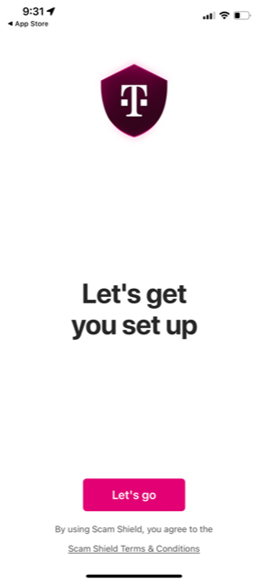

**Step 4: Caller ID Step – Click “Got It”**

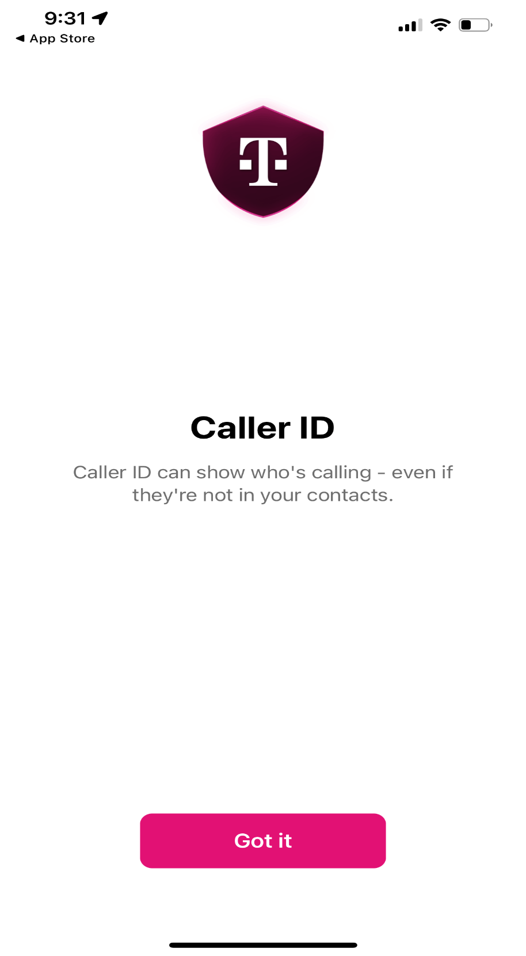

**Step 5:** Simple Call Reporting – Click “Got It”

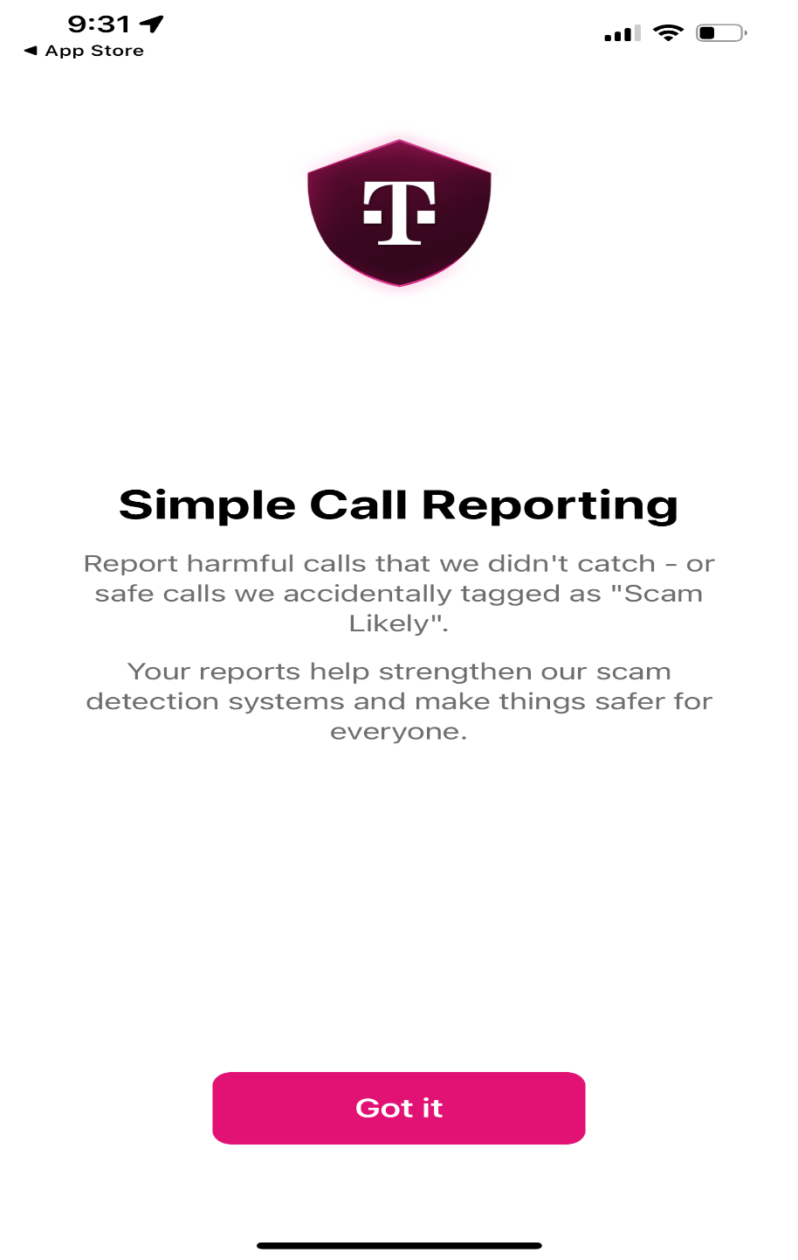

**Step 6** : You’re all set screen – Click “Got It”

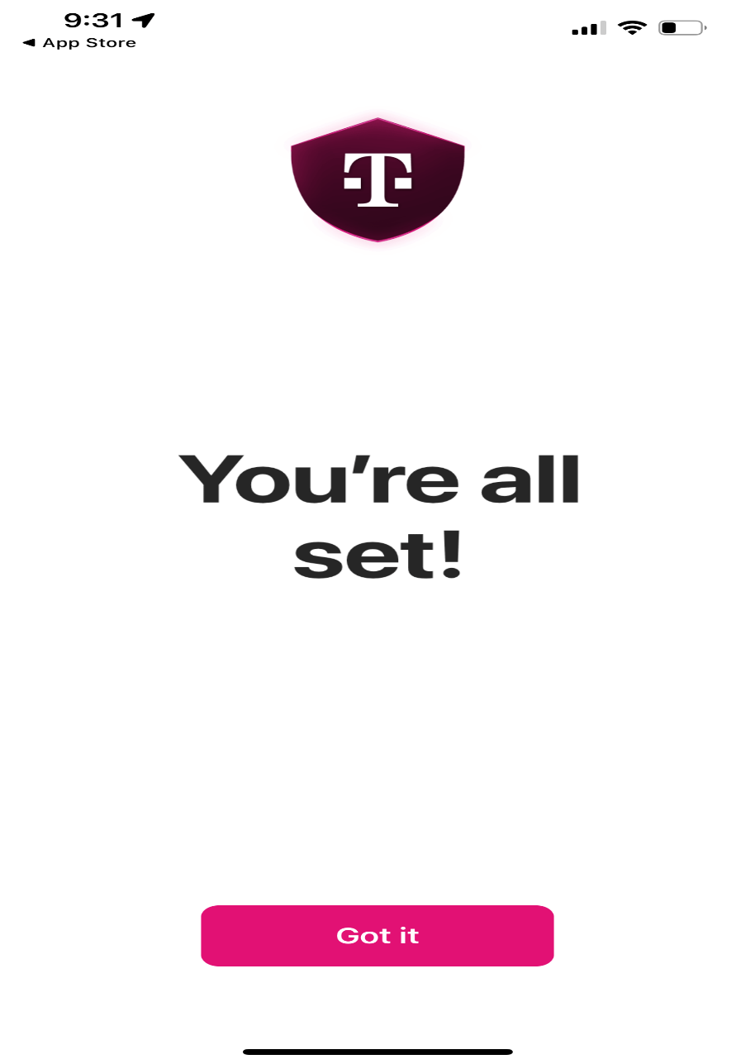

**Step 7:** Click Manage on the bottom menu bar

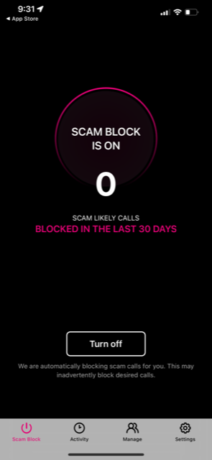

**Step 8:** Click “Allow a number”

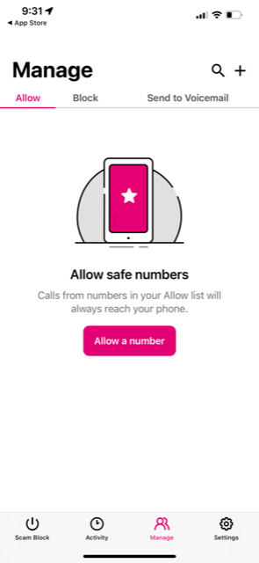

**Step 9:** Type in the Monte Carlo Gate Number – (954) 960-2524

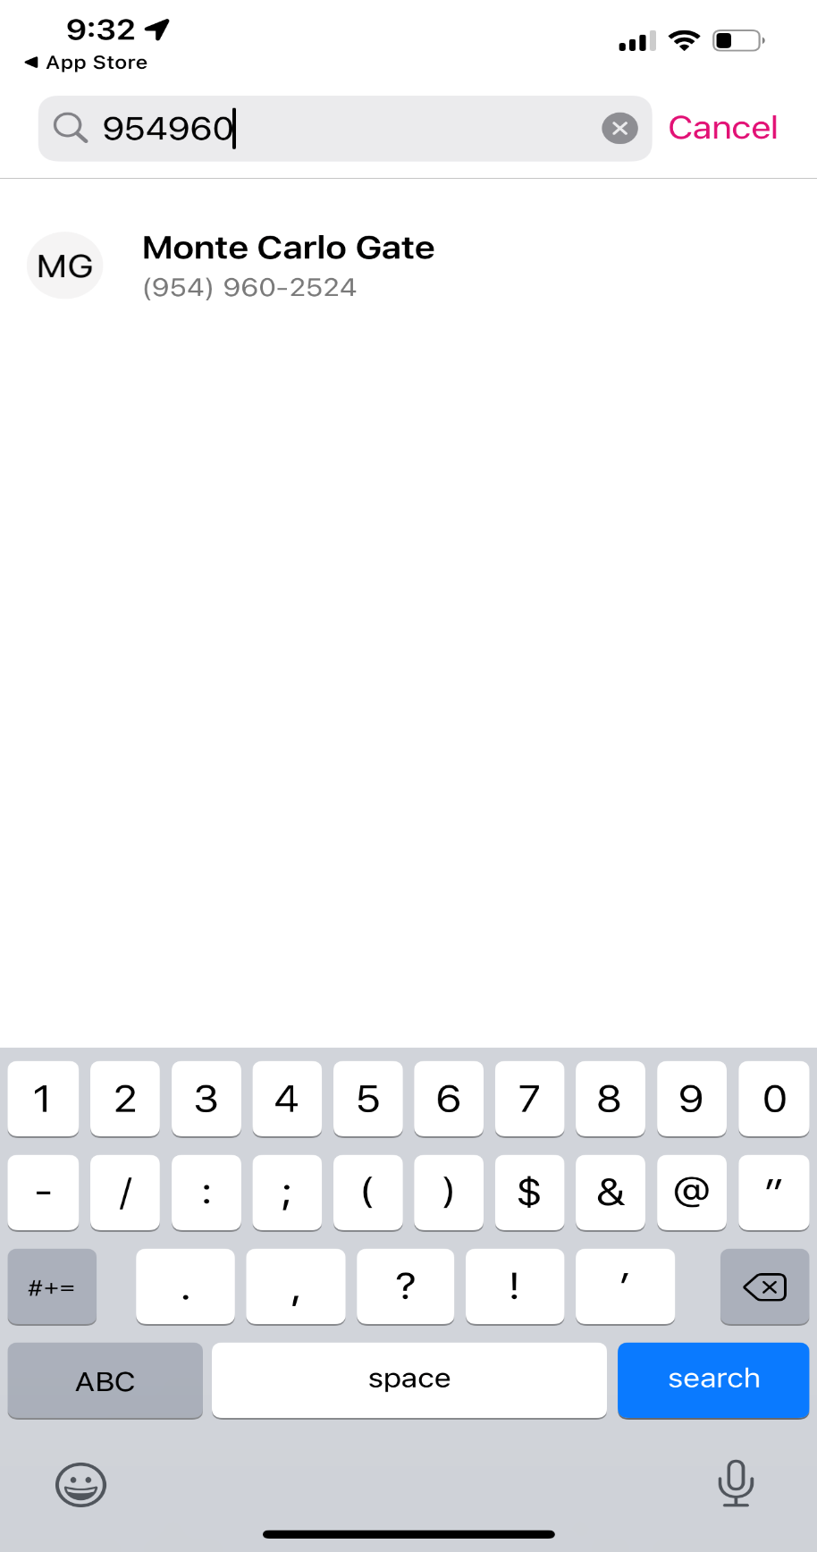

**Step 10:** The number / contact will display on the screen

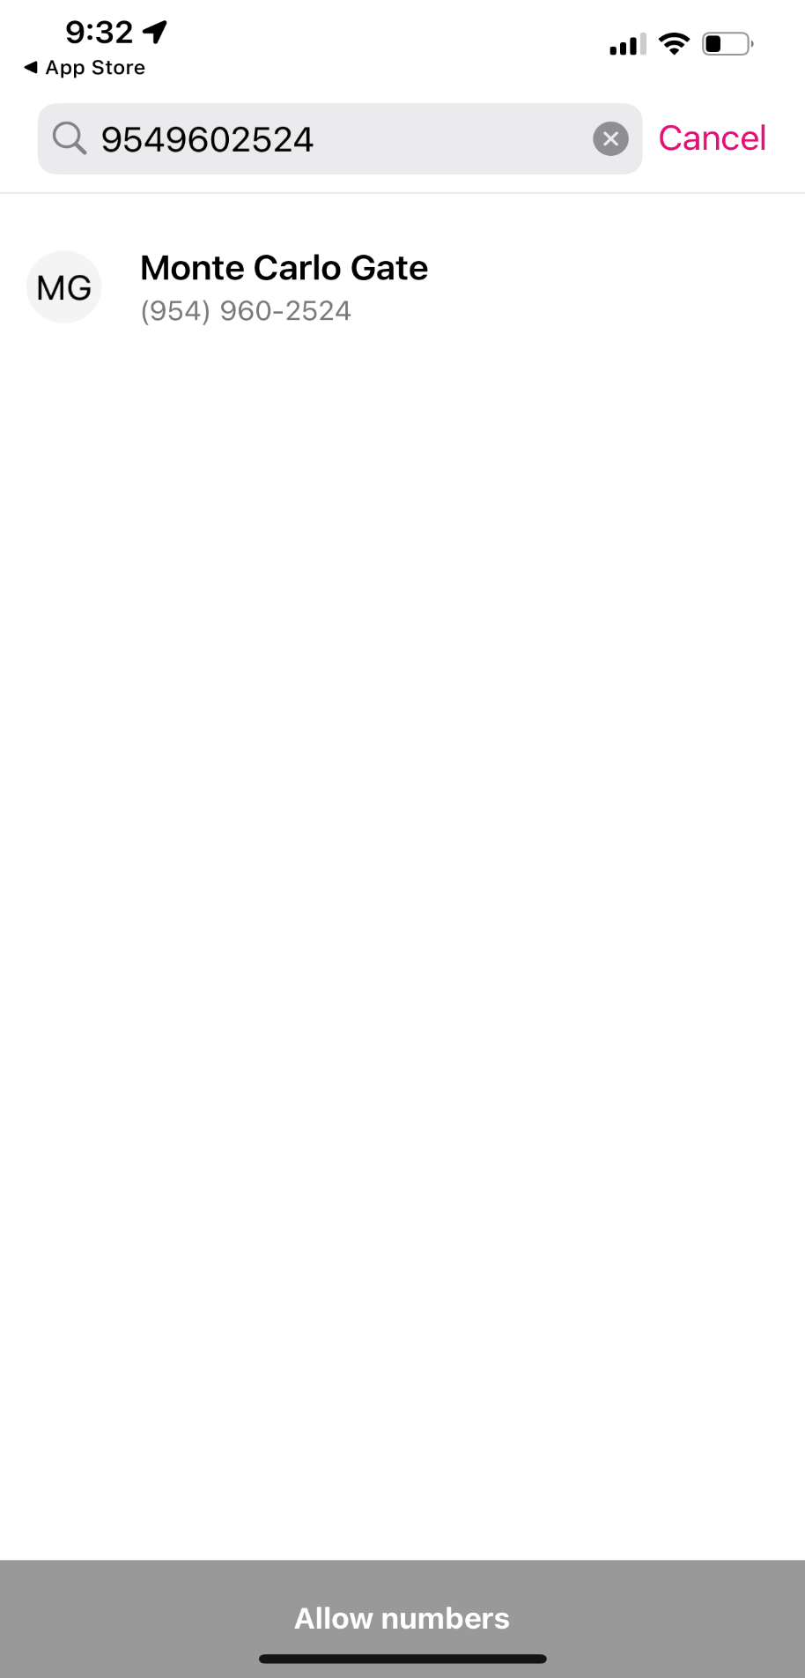

**Step 11:** Click the number or the bubble next to the number to get a check mark to display and the “allow numbers” button to turn pink

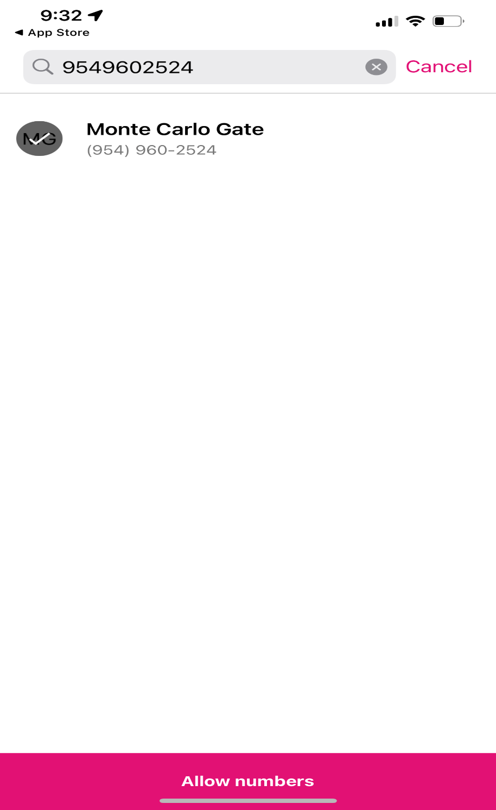

**Step 12:** Click the “Allow Number” button. This will allow the gate number to reach your phone.

A message “Number added to the allow list” will be displayed on the screen.

